Lab 4B – Understanding WAN Concepts - Worksheet

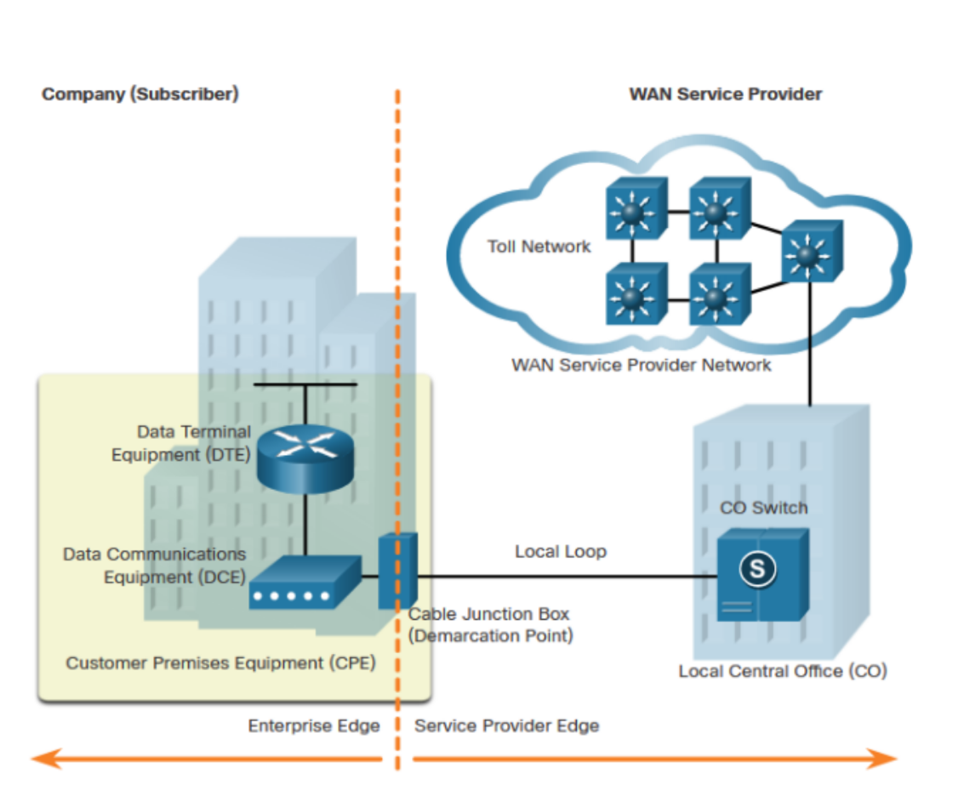

Explain the term **Enterprise Edge** and give meaning to the acronyms and terms listed below in your own words:

Enterprise Edge is the side of the network that belongs to the company.

1. DTE: **Data Terminal Equipment** is the Router or device used to connect the company’s local networks to the Service Provider’s network or the Internet.
2. DCE: **Data Communications Equipment** is used to send data / communicate with the ISP.
3. CPE: **Customer Premises Equipment** are devices that all face and are on the customer side or location.
4. Demarcation Point: **Demarcation Point** is where the customer and internet supplier connections meet.

Explain the term **Service Provider Edge** and give meaning to the acronyms and terms listed below in your own words:   
  
Service Provider Edge is the side of the network that belongs to and managed by the Internet Service Supplier.

1. Local Loop: The wire / medium used between the Demarcation point and the ISP.
2. Local Central Office (CO): Office where Customer Edge Side connects to Service Provider.
3. WAN Service Provider network: The networks the Service Provider is connected to.
4. Toll Network: The equipment inside of the WAN service provider.

Packet tracer activity

1. Speak to the medium types that were used in each network space [business/cellular/home] (provide some reasoning as to why a particular medium type is in use on the customer edge vs the enterprise edge)

The Enterprise edge had fiber optic cables between the switches, most likely because there is a lot of traffic going on in the company and fiber optic cables will provide faster and more reliable communications across large distances.

The Customer side has coaxial and digital subscriber line (phone). Coaxial cable probably because one of the customers are using cable and watching tv.

1. Is NAT being used? If it is, point out the devices conducting NAT. Why is NAT being used?

Yes Nat is being used, the Wireless Routers and Business Headquarter routers are using Nat to translate from internal networks to external networks.

1. In the packet tracer activity, you were asked to conduct a ping test. Speak to why some of the ping tests failed.

Some of the pings failed because it is trying to ping an IP to an internal network using an internal addresss.

1. Is there a single point of failure on the business network? Explain what it is and what can be done to rectify it. (Review the types of WAN topologies in module 7 to help you with your answer.)

**T**here is only one point of connection to the Service Network, you can mitigate the risk by connecting to the backbone network.

1. Provide a summary of what you discovered and learned as you explored the packet tracer WAN activity.

Enterprise and consumers connect their internal networks to the Internet using Modems to send data across large distances to the Service Provider.